Name:______________________ Date:_______________

Directions: You may use a calculator to complete this test.

Solve the system of equations by the substitution method.

1. 

Solve the system of equations by the elimination method.

1. 

Solve the system of equations using an augmented matrix (Gauss -Jordan).

1. 

Graph the system and state the solution.

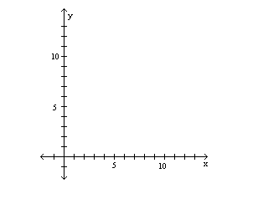

1. 

Solve the system using the inverse matrix method.

1.  
2. A company manufactures three types of wooden chairs: the Kitui, the Goa, and the Santa Fe. To make a Kitui chair requires 1 hour of cutting time, 1.5 hours of assembly time, and 1 hour of finishing time. A Goa chair requires 1.5 hours of cutting time, 2.5 hours of assembly time and 2 hours of finishing time. A Santa Fe chair requires 1.5 hours of cutting time, 3 hours of assembly time, and 3 hours of finishing time. If 41 hours of cutting time, 70 hours of assembly time, and 58 hours of finishing time were used one week, how many of each type of chair were produced? **Only write the augmented matrix. DO NOT SOLVE!!**
3. Perform the row operation  on the matrix 
4. Let A =  and B =. Find 3A + 2B.
5. Compute the Product. 
6. Compute the Product. 

Solve the nonlinear system of equations.

1. 
2. The sum of the squares of two numbers is 68. The difference of the numbers is 10. Find the two numbers.

Graph the system of inequalities.

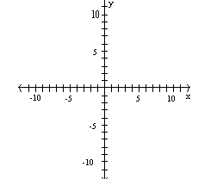

1. 

Graph the system of inequalities.



1. 
2. Find the inverse of . Be sure to check your answer through multiplication.